Configurações opcionais, talvez referentes ao Wordpress!

Vai ter docs apenas para wordpress

## **www-data**

Now we need to set www-data (Apache user) as the owner of document root (otherwise known as web root). By default it’s owned by the root user.

$ la -la /var/www/html

chown www-data:www-data /var/www/html/*

**Apache Canonical Hostnames – como redirecionar uma URL antiga para uma nova**

<VirtualHost *:80>

ServerName m.smartdicas.com

Redirect / <http://www.smartdicas.com/>

</VirtualHost>

**Isso vai fazer a URL**: <http://m.smartdicas.com/videos/teste>

**redirecionar para**:  <http://www.smartdicas.com/videos/teste>

**Personalizar pagina de erro Not Found 404**

ErrorDocument 404 /var/www/erros_pages/404.html

ErrorDocument 404 http://meusite.com/404.html

**How To Fix Permalink 404 not found – method 2**

I've been searching for this issue i had and i managed to fix it gladly with some search but i didn't find anyone fixed it here so

first of all create .htaccess on your website directory it could be /var/www/yourwebsite or any where you installed wordpress on (just move it beside wp-config.php)  
this tutorial require ssh connection i edited this from Terminal after i connected to my Debian/Linux server

in command line you can make touch .htaccess and then set permission chmod 666 .htaccess and chown www-data:www-data .htaccess

then change your permalink to default > save it, and then once again, change permalink back to Post Name  
you should see in .htaccess something like

.

Now from command line you should enable rewrite_mod by typing (you need to be root)  
a2enmod rewrite

and then restart apache by  
/etc/init.d/apache2 restart

and this fixed the issue for me :)  
hope it fixes yours and this is my first English 'how to' tutorial

**Ou no Apache**

$ sudo vim /etc/apache2/apache2.conf

**Alterar Linha 164**

AllowOverride None para AllowOverride All

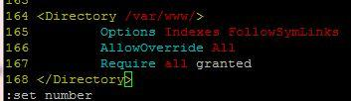

**2021 UPDATE:** Se faz necessário alterar as linhas 161 e 172 respectivamente de **None** para **All**

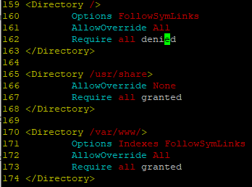

Change Apache default port to a custom port

1. Change Apache port on Debian/Ubuntu

Edit **/etc/apache2/ports.conf** file,

sudo vi /etc/apache2/ports.conf

Find the following line:

Listen 80

And change it to a random number of your choice, for example **8090**.

Listen 8090

This entry make the server to accept connections on port 8090 on all interfaces. To make the server accept connections on port 8090 for a specific interface, just include the corresponding network interface’s IP address as shown below.

Listen 192.168.1.101:8090

This will be helpful if your server has multiple IP addresses or network interfaces.

Save and close the file.

Additionally, in Ubuntu and Debian, you will likely also have to change the port number in **/etc/apache2/sites-enabled/000-default.conf** file too.

sudo vi /etc/apache2/sites-enabled/000-default.conf

Find the following line and change the port number.

<VirtualHost *:8090>

Save and close the file.

Then, restart Apache service to take effect the changes.

sudo systemctl restart apache2

Or

sudo service apache2 restart

Now let us verify the port settings:

sudo netstat -tulpn | grep :8090

Sample output:

tcp6       0      0 :::8090                 :::*                    LISTEN      4066/apache2

Then, open your web browser and navigate to URL: **http://IP-address:8090**

.